|  |  |
| --- | --- |
| **DATE** | **4NOV 2022** |
| **TEAMID** | **PNT2022TMID26869** |
| **PROJECTNAME** | **SMARTWASTEMANAGEMENTSYSTEM**  **FORMETROPOLITANCITIES** |
| **MAXIMUMMARKS** | **4 Marks** |

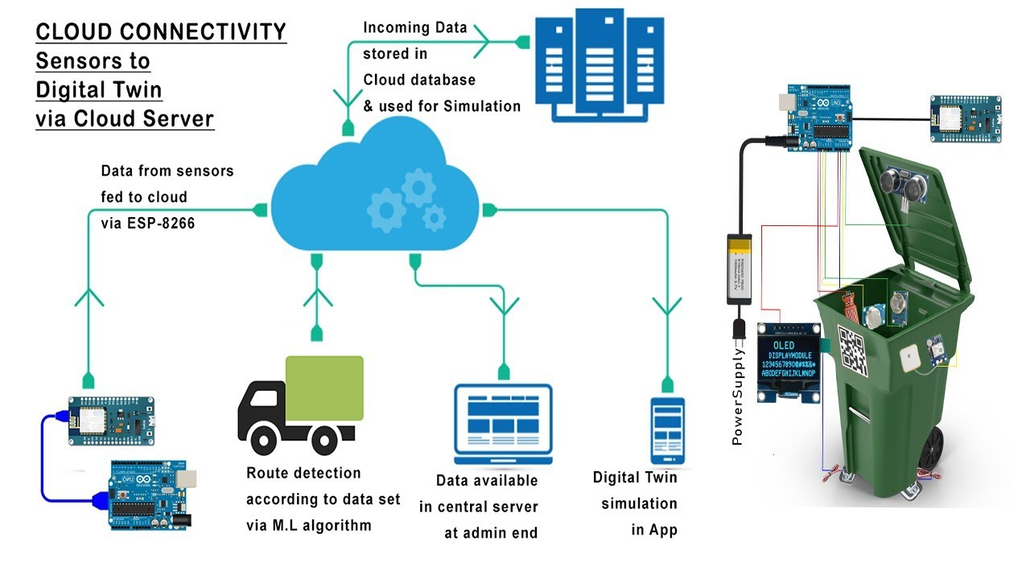**TECHNICALARCHITECTURE:**

**Guidelines:**

1. Our proposedmodel providerealtimemonitoringtothe garbagebinsplacedinvarious locations.
2. The garbage bins are build with a sensor module(Ultrasonic sensor) which continuosly monitors the garbage bin.

**Table-1:Components&Technologies:**

|  |  |  |  |
| --- | --- | --- | --- |
| **S.No** | **Component** | **Description** | **Technology** |
| 1. | UserInterface | How user interacts withapplication e.g.WebUI,  MobileApp,Chatbotetc. | HTML,CSS,JavaScript/AngularJs/React Jsetc. |
| 2. | ApplicationLogic-1 | Logicforaprocessintheapplication | Java/Python |
| 3. | ApplicationLogic-2 | Logicforaprocessintheapplication | IBMWatsonSTTservice |
| 4. | ApplicationLogic-3 | Logicforaprocessintheapplication | IBMWatsonAssistant |
| 5. | Database | DataType,Configurationsetc. | MySQL,NoSQL,etc. |
| 6. | CloudDatabase | DatabaseServiceonCloud | IBMDB2,IBMCloudantetc. |
| 7. | FileStorage | Filestoragerequirements | IBMBlockStorageorOtherStorage  ServiceorLocalFilesystem |
| 8. | ExternalAPI-1 | PurposeofExternalAPIusedintheapplication | IBMWeatherAPI,etc. |
| 9. | ExternalAPI-2 | PurposeofExternalAPIusedintheapplication | AadharAPI,etc. |
| 10. | MachineLearningModel | PurposeofMachineLearningModel | ObjectRecognitionModel, etc. |
| 11. | Infrastructure(Server/Cloud) | ApplicationDeploymentonLocalSystem / CloudLocal ServerConfiguration:  CloudServerConfiguration: | Local,CloudFoundry,Kubernetes,etc. |

**Table-2:ApplicationCharacteristics:**

|  |  |  |  |
| --- | --- | --- | --- |
| **S.No** | **Characteristics** | **Description** | **Technology** |
| 1. | Open-SourceFrameworks | Listtheopen-sourceframeworksused | TechnologyofOpensourceframework |
| 2. | SecurityImplementations | Listallthesecurity/accesscontrolsimplemented,useoffirewalls etc. | e.g. SHA-256, Encryptions,IAMControls,OWASPetc. |
| 3. | ScalableArchitecture | Justify the scalability of architecture (3 – tier,Micro-services) | Technology used |
| 4. | Availability | Justifytheavailabilityofapplication(e.g. useofloadbalancers,distributedserversetc.) | Technology used |
| 5. | Performance | Design consideration for the performance of theapplication (number of requests per sec, use ofCache, useofCDN’s)etc. | Technology used |